
Database Management System (DBMS) Project

Project Title: Movie Ticket Booking System

Department of Computer Science and Engineering
Course Code: CSE 211
Course Title: Database Management System

Submitted By (Group Members):
Student Name | Student ID
Zakeria Abrar | 23201061
Naziz Al Sayem | 23201072
Shakil Ahmed | 23201077
Jobair Ahmed | 23201069

Submitted To:
Nadeem Ahmed
Assistant Professor, Department of Computer Science and Engineering
University of Asia Pacific

Submission Date: 20/10/2025

Task-1

Topic Selection

Project Name: Movie Ticket Booking System
I chose the Movie Ticket Booking System project because it provides a convenient and efficient way for users to book movie tickets online. The system allows customers to browse movies, view showtimes, select seats, and make payments digitally, eliminating the need for manual or offline booking. It also supports promotional offers and customer feedback, enhancing user engagement and satisfaction. This project not only streamlines theatre operations but also offers a practical opportunity to apply database management, real-time transaction handling, and user interface design in a real-world scenario.

Task-2

Project Description

Project Overview:
The Movie Ticket Booking System is designed to allow users to browse movies, select showtimes, choose seats, and make bookings easily. The system manages theatres, movies, shows, customers, bookings, and payments in an organized relational database.

Key Features:
- Movie Listings: Browse available movies with details like title, genre, duration, rating, and release date.
- Showtime Scheduling: View all showtimes for each movie, linked to specific screens and theatres.
- Seat Selection: Real-time seat availability and selection for each showtime.
- Online Booking & Payment: Book tickets digitally and pay securely through multiple payment methods.
- Ticket Generation: Receive digital tickets with unique IDs or QR codes for verification.
- Promotional Offers: Apply discount codes or special offers to bookings automatically.
- Customer Feedback: Rate movies and provide comments to help improve theatre services.
- Booking History: View past bookings and manage upcoming reservations.
- Staff & Theatre Management: Track theatre staff and manage multiple screens efficiently.

Task-3

Identifying Entities & ER Diagram

Movie Ticket Booking System — Entities, Descriptions, and Relationships
Entity | Description | Relationship
Theatre | Stores information about movie theatres including name, location, and contact info. | One Theatre → Many Screens. One Theatre → Many Staff.
Screen | Represents individual screens in a theatre where movies are shown. | One Screen → Many Showtimes.
Movie | Stores movie details like title, genre, duration, rating, and release date. | One Movie → Many Showtimes. One Movie → Many Feedback entries.
Showtime | Represents specific show timings for movies on a particular screen. | One Showtime → Many Seats and many bookings
Seat | Represents individual seats for each showtime with type, price, and booking status. | One Seat → Many Tickets.
Customer | Contains customer details such as name, email, phone, and address. | One Customer → Many Bookings. One Customer → Many Feedback entries.
Booking | Stores information about a customer's movie booking, showtime, and total amount. | One Booking → One Payment. One Booking → Many Tickets.
Payment | Records payment details for bookings, including method, amount, and status. | One Booking → One Payment.
Ticket | Represents a physical or digital ticket for a booked seat. | One Booking → Many Tickets. One Seat → Many Tickets.
Staff | Stores information about theatre staff members including role and contact info. | One Theatre → Many Staff.
Offer | Contains promotional offers or discounts available for bookings. | Many-to-Many with Booking via Booking_Offers.
Feedback | Stores customer feedback on movies including rating and comments. | One Customer → Many Feedback. One Movie → Many Feedback.
Booking_Offers | Bridge table linking Booking and Offer entities showing which offers apply to which bookings. | Many-to-Many Relationship between Booking and Offer.

ER Diagram:
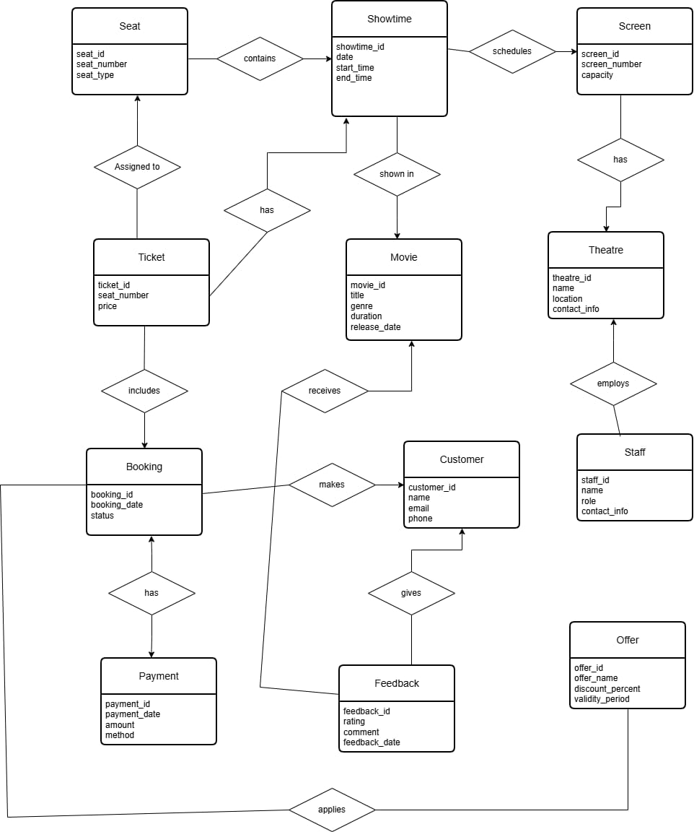

Task-4
Schema Diagram:
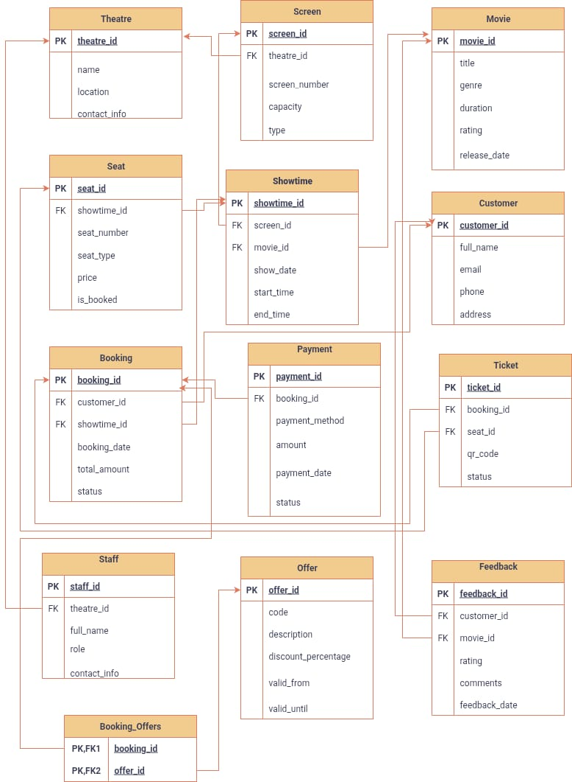

Task-5
Table Creation:
create database MovieTicketBookingSystem
use MovieTicketBookingSystem
Go

CREATE TABLE Theatre (
theatre_id INT PRIMARY KEY IDENTITY(1,1),
name VARCHAR(100),
location VARCHAR(100),
contact_info VARCHAR(50)
);
CREATE TABLE Screen (
screen_id INT PRIMARY KEY IDENTITY(1,1),
theatre_id INT,
screen_number VARCHAR(10),
capacity INT,
type VARCHAR(50),
FOREIGN KEY (theatre_id) REFERENCES Theatre(theatre_id)
);
CREATE TABLE Movie (
movie_id INT PRIMARY KEY IDENTITY(1,1),
title VARCHAR(100),
genre VARCHAR(50),
duration INT, --minutes
rating VARCHAR(10),
release_date DATE
);
CREATE TABLE Showtime (
showtime_id INT PRIMARY KEY IDENTITY(1,1),
screen_id INT,
movie_id INT,
show_date DATE,
start_time TIME,
end_time TIME,
FOREIGN KEY (screen_id) REFERENCES Screen(screen_id),
FOREIGN KEY (movie_id) REFERENCES Movie(movie_id)
);
CREATE TABLE Seat (
seat_id INT PRIMARY KEY IDENTITY(1,1),
showtime_id INT,
seat_number VARCHAR(10),
seat_type VARCHAR(20),
price DECIMAL(8,2),
is_booked BIT DEFAULT 0,
FOREIGN KEY (showtime_id) REFERENCES Showtime(showtime_id)
);
CREATE TABLE Customer (
customer_id INT PRIMARY KEY IDENTITY(1,1),
full_name VARCHAR(100),
email VARCHAR(100),
phone VARCHAR(20),
address VARCHAR(150)
);
CREATE TABLE Booking (
booking_id INT PRIMARY KEY IDENTITY(1,1),
customer_id INT,
showtime_id INT,
booking_date DATETIME DEFAULT GETDATE(),
total_amount DECIMAL(10,2),
status VARCHAR(20) DEFAULT 'Pending',
FOREIGN KEY (customer_id) REFERENCES Customer(customer_id),
FOREIGN KEY (showtime_id) REFERENCES Showtime(showtime_id)
);
CREATE TABLE Payment (
payment_id INT PRIMARY KEY IDENTITY(1,1),
booking_id INT,
payment_method VARCHAR(30),
amount DECIMAL(10,2),
payment_date DATETIME DEFAULT GETDATE(),
status VARCHAR(20),
FOREIGN KEY (booking_id) REFERENCES Booking(booking_id)
);
CREATE TABLE Ticket (
ticket_id INT PRIMARY KEY IDENTITY(1,1),
booking_id INT,
seat_id INT,
qr_code VARCHAR(200),
status VARCHAR(20),
FOREIGN KEY (booking_id) REFERENCES Booking(booking_id),
FOREIGN KEY (seat_id) REFERENCES Seat(seat_id)
);
CREATE TABLE Staff (
staff_id INT PRIMARY KEY IDENTITY(1,1),
theatre_id INT,
full_name VARCHAR(100),
role VARCHAR(50),
contact_info VARCHAR(50),
FOREIGN KEY (theatre_id) REFERENCES Theatre(theatre_id)
);
CREATE TABLE Offer (
offer_id INT PRIMARY KEY IDENTITY(1,1),
code VARCHAR(20),
description VARCHAR(150),
discount_percentage DECIMAL(5,2),
valid_from DATE,
valid_until DATE
);
CREATE TABLE Feedback (
feedback_id INT PRIMARY KEY IDENTITY(1,1),
customer_id INT,
movie_id INT,
rating INT CHECK (rating BETWEEN 1 AND 5),
comments VARCHAR(300),
feedback_date DATETIME DEFAULT GETDATE(),
FOREIGN KEY (customer_id) REFERENCES Customer(customer_id),
FOREIGN KEY (movie_id) REFERENCES Movie(movie_id)
);
CREATE TABLE Booking_Offers (
booking_id INT,
offer_id INT,
PRIMARY KEY (booking_id, offer_id),
FOREIGN KEY (booking_id) REFERENCES Booking(booking_id),
FOREIGN KEY (offer_id) REFERENCES Offer(offer_id)
);

Data Insertion:
INSERT INTO Theatre (name, location, contact_info) VALUES
('Silver Screen Cinema','Dhaka','01710000001'),
('Galaxy Multiplex','Chittagong','01710000002'),
('Starview Cinemas','Sylhet','01710000003'),
('CineMagic Hub','Khulna','01710000004'),
('Royal Reel Theatre','Barishal','01710000005'),
('Cinepolis Dhaka','Rajshahi','01710000006'),
('Infinity Cinema','Rangpur','01710000007'),
('Grand Film House','Comilla','01710000008'),
('Lumina Cinemas','Mymensingh','01710000009'),
('Premiere Plaza','Jessore','01710000010'),
('Starlight Theatre','Bogra','01710000011'),
('Aurora Cinema','Pabna','01710000012'),
('Celestial Cinemas','Narsingdi','01710000013'),
('Regal Screens','Tangail','01710000014'),
('Eclipse Multiplex','Dinajpur','01710000015');

INSERT INTO Screen (theatre_id, screen_number, capacity, type) VALUES
(1,'S1',120,'Standard'),
(1,'S2',80,'VIP'),
(2,'S1',150,'Standard'),
(2,'S2',90,'VIP'),
(3,'S1',100,'Standard'),
(3,'S2',70,'VIP'),
(4,'S1',130,'Standard'),
(4,'S2',60,'VIP'),
(5,'S1',140,'Standard'),
(5,'S2',100,'VIP'),
(6,'S1',120,'Standard'),
(7,'S1',110,'Standard'),
(8,'S1',130,'Standard'),
(9,'S1',100,'Standard'),
(10,'S1',120,'Standard');

INSERT INTO Movie (title, genre, duration, rating, release_date) VALUES
('Midnight Chase','Action',120,'PG-13','2025-01-01'),
('Love in Paris','Romance',110,'PG','2025-01-05'),
('Ghost Hunter','Horror',100,'R','2025-02-10'),
('Galaxy Wars','Sci-Fi',140,'PG-13','2025-03-15'),
('The Last Kingdom','Action',130,'PG-13','2025-04-20'),
('Comedy Nights','Comedy',105,'PG','2025-05-01'),
('Heartstrings','Romance',115,'PG','2025-06-10'),
('The Haunted Mansion','Horror',120,'R','2025-07-05'),
('Adventure Quest','Adventure',125,'PG-13','2025-08-01'),
('Dreamscape','Fantasy',130,'PG','2025-08-15'),
('Silent Shadows','Thriller',110,'R','2025-09-01'),
('Ocean’s Secret','Mystery',120,'PG-13','2025-09-10'),
('Starfall','Sci-Fi',140,'PG-13','2025-10-01'),
('Laugh Riot','Comedy',100,'PG','2025-10-10'),
('Eternal Flame','Romance',135,'PG','2025-10-12');

INSERT INTO Showtime (screen_id, movie_id, show_date, start_time, end_time) VALUES
(1,1,'2025-10-15','10:00','12:00'),
(2,2,'2025-10-15','13:00','15:00'),
(3,3,'2025-10-16','10:00','12:00'),
(4,4,'2025-10-16','13:00','15:20'),
(5,5,'2025-10-17','11:00','13:10'),
(6,6,'2025-10-17','14:00','15:45'),
(7,7,'2025-10-18','10:30','12:25'),
(8,8,'2025-10-18','13:30','15:30'),
(9,9,'2025-10-19','10:00','12:05'),
(10,10,'2025-10-19','13:00','15:10'),
(1,11,'2025-10-20','11:00','12:50'),
(2,12,'2025-10-20','13:30','15:30'),
(3,13,'2025-10-21','10:00','12:20'),
(4,14,'2025-10-21','12:30','14:10'),
(5,15,'2025-10-22','11:00','13:15');

INSERT INTO Seat (showtime_id, seat_number, seat_type, price) VALUES
(1,'A1','Regular',200),(1,'A2','Regular',200),(1,'A3','VIP',400),
(2,'A1','Regular',200),(2,'A2','VIP',400),
(3,'B1','Regular',200),(3,'B2','VIP',400),
(4,'B1','Regular',200),(4,'B2','VIP',400),
(5,'C1','Regular',200),(5,'C2','VIP',400),
(6,'C1','Regular',200),(6,'C2','VIP',400),
(7,'D1','Regular',200),(7,'D2','VIP',400);

INSERT INTO Customer (full_name, email, phone, address) VALUES
('Ayesha Rahman','ayesha@example.com','01720000001','Dhaka'),
('Imran Hossain','imran@example.com','01720000002','Chittagong'),
('Zara Ahmed','zara@example.com','01720000003','Sylhet'),
('Rafiq Chowdhury','rafiq@example.com','01720000004','Khulna'),
('Tania Islam','tania@example.com','01720000005','Barishal'),
('Arif Khan','arif@example.com','01720000006','Rajshahi'),
('Nabila Sultana','nabila@example.com','01720000007','Rangpur'),
('Omar Faruk','omar@example.com','01720000008','Comilla'),
('Sohana Akter','sohana@example.com','01720000009','Mymensingh'),
('Fahim Reza','fahim@example.com','01720000010','Jessore'),
('Laila Hasan','laila@example.com','01720000011','Bogra'),
('Tanvir Rahman','tanvir@example.com','01720000012','Pabna'),
('Shaila Roy','shaila@example.com','01720000013','Narsingdi'),
('Arman Siddique','arman@example.com','01720000014','Tangail'),
('Meher Ali','meher@example.com','01720000015','Dinajpur');

INSERT INTO Booking (customer_id, showtime_id, total_amount, status) VALUES
(1,1,200,'Confirmed'),(2,2,400,'Pending'),
(3,3,200,'Confirmed'),(4,4,400,'Confirmed'),
(5,5,200,'Pending'),(6,6,400,'Confirmed'),
(7,7,200,'Pending'),(8,8,400,'Confirmed'),
(9,9,200,'Confirmed'),(10,10,400,'Pending'),
(11,11,200,'Confirmed'),(12,12,400,'Confirmed'),
(13,13,200,'Pending'),(14,14,400,'Confirmed'),
(15,15,200,'Confirmed');

INSERT INTO Payment (booking_id, payment_method, amount, status) VALUES
(1,'Card',200,'Completed'),
(2,'Cash',400,'Pending'),
(3,'Card',200,'Completed'),
(4,'Online',400,'Completed'),
(5,'Cash',200,'Pending'),
(6,'Card',400,'Completed'),
(7,'Online',200,'Pending'),
(8,'Card',400,'Completed'),
(9,'Cash',200,'Completed'),
(10,'Online',400,'Pending'),
(11,'Card',200,'Completed'),
(12,'Cash',400,'Completed'),
(13,'Online',200,'Pending'),
(14,'Card',400,'Completed'),
(15,'Cash',200,'Completed');

INSERT INTO Ticket (booking_id, seat_id, qr_code) VALUES
(1,1,'QR001'),(2,2,'QR002'),(3,3,'QR003'),(4,4,'QR004'),
(5,5,'QR005'),(6,6,'QR006'),(7,7,'QR007'),(8,8,'QR008'),
(9,9,'QR009'),(10,10,'QR010'),(11,11,'QR011'),(12,12,'QR012'),
(13,13,'QR013'),(14,14,'QR014'),(15,15,'QR015');

INSERT INTO Staff (theatre_id, full_name, role, contact_info) VALUES
(1,'Rashed Alam','Manager','01730000001'),
(1,'Sumaiya Rahman','Usher','01730000002'),
(2,'Tanvir Hossain','Manager','01730000003'),
(2,'Farzana Akter','Usher','01730000004'),
(3,'Arif Khan','Manager','01730000005'),
(3,'Nabila Sultana','Usher','01730000006'),
(4,'Rahim Chowdhury','Manager','01730000007'),
(4,'Samira Ahmed','Usher','01730000008'),
(5,'Imran Siddique','Manager','01730000009'),
(5,'Amina Hasan','Usher','01730000010'),
(6,'Rafiq Roy','Manager','01730000011'),
(6,'Tanisha Faruk','Usher','01730000012'),
(7,'Shaila Khan','Manager','01730000013'),
(7,'Arman Reza','Usher','01730000014'),
(8,'Mia Ali','Manager','01730000015');

INSERT INTO Offer (code, description, discount_percentage, valid_from, valid_until) VALUES
('NEW10','10% off New Year',10,'2025-01-01','2025-01-31'),
('FUN20','20% Fun Offer',20,'2025-02-01','2025-02-28'),
('HALF30','30% Mid-Year',30,'2025-06-01','2025-06-30'),
('SUMMER40','Summer Offer 40%',40,'2025-07-01','2025-07-31'),
('FEST50','Festival Special 50%',50,'2025-12-01','2025-12-31'),
('DISC5','5% Discount',5,'2025-01-01','2025-12-31'),
('DISC15','15% Discount',15,'2025-01-01','2025-12-31'),
('DISC25','25% Discount',25,'2025-01-01','2025-12-31'),
('PROMO35','35% Promo',35,'2025-01-01','2025-12-31'),
('PROMO10','10% Promo',10,'2025-01-01','2025-12-31'),
('PROMO20','20% Promo',20,'2025-01-01','2025-12-31'),
('PROMO30','30% Promo',30,'2025-01-01','2025-12-31'),
('PROMO40','40% Promo',40,'2025-01-01','2025-12-31'),
('PROMO50','50% Promo',50,'2025-01-01','2025-12-31'),
('NEWYEAR','New Year 25% off',25,'2025-12-25','2026-01-05');

INSERT INTO Feedback (customer_id, movie_id, rating, comments) VALUES
(1,1,5,'Thrilling experience!'),(2,2,4,'Loved the romance'),
(3,3,3,'Average horror'),(4,4,2,'Too many sci-fi scenes'),
(5,5,5,'Action-packed!'),(6,6,4,'Funny movie'),
(7,7,3,'Heartwarming'),(8,8,5,'Scary but good'),
(9,9,4,'Adventure worth watching'),(10,10,3,'Nice fantasy'),
(11,11,2,'Not thrilling'),(12,12,4,'Interesting mystery'),
(13,13,5,'Amazing visuals'),(14,14,4,'Laugh riot'),(15,15,5,'Romantic and touching');

INSERT INTO Booking_Offers (booking_id, offer_id) VALUES
(1,1),(2,2),(3,3),(4,4),(5,5),
(6,6),(7,7),(8,8),(9,9),(10,10),
(11,11),(12,12),(13,13),(14,14),(15,15);

Task-6

Query

--1 List all theatres
SELECT * FROM Theatre;

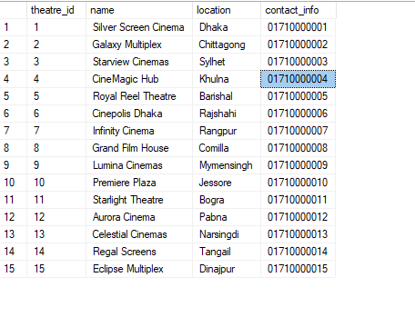
--2 List all movies

SELECT * FROM Movie;
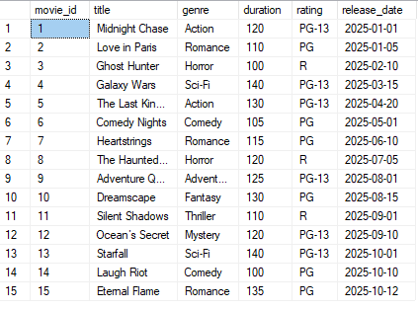
--3 List all customers
SELECT full_name, email, phone FROM Customer;
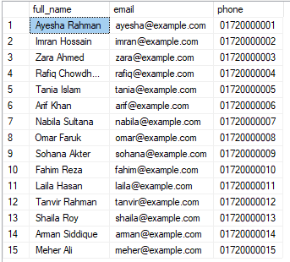

--4 List all showtimes for a specific movie
SELECT show_date, start_time, end_time
FROM Showtime
WHERE movie_id = 1;
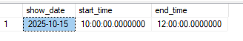

--5 Show seats for a showtime
SELECT seat_number, seat_type, price, is_booked
FROM Seat
WHERE showtime_id = 1;
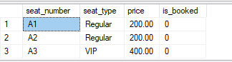

--6 Show bookings with customer names
SELECT b.booking_id, c.full_name, b.total_amount, b.status
FROM Booking b
JOIN Customer c ON b.customer_id = c.customer_id;
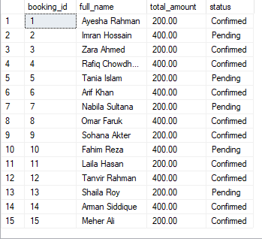
--7 Show tickets with seat numbers
SELECT t.ticket_id, b.booking_id, seat.seat_number
FROM Ticket t
JOIN Seat seat ON t.seat_id = seat.seat_id
JOIN Booking b ON t.booking_id = b.booking_id;
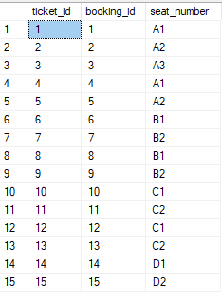
--8 Show all completed payments
SELECT payment_id, booking_id, amount, payment_method
FROM Payment
WHERE status = 'Completed';
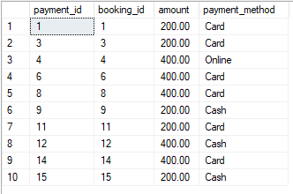
--9 Show feedback with rating 4 or higher
SELECT c.full_name, m.title, f.rating, f.comments
FROM Feedback f
JOIN Customer c ON f.customer_id = c.customer_id
JOIN Movie m ON f.movie_id = m.movie_id
WHERE f.rating >= 4;
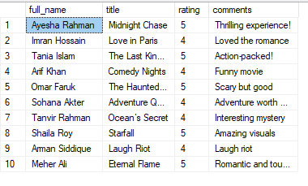
--10 Count total bookings
SELECT COUNT(*) AS total_bookings FROM Booking;

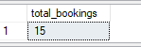

--11 Average movie rating
SELECT m.title, AVG(f.rating) AS avg_rating
FROM Feedback f
JOIN Movie m ON f.movie_id = m.movie_id
GROUP BY m.title;

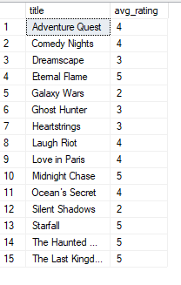
--12 List top 5 movies by average rating
SELECT TOP 5 m.title, AVG(f.rating) AS avg_rating
FROM Feedback f
JOIN Movie m ON f.movie_id = m.movie_id
GROUP BY m.title
ORDER BY avg_rating DESC;
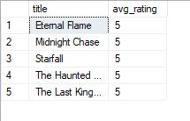

--13 List bookings with applied offers
SELECT b.booking_id, c.full_name, o.code, o.discount_percentage
FROM Booking_Offers bo
JOIN Booking b ON bo.booking_id = b.booking_id
JOIN Offer o ON bo.offer_id = o.offer_id
JOIN Customer c ON b.customer_id = c.customer_id;
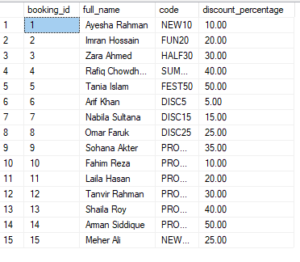

--14 Most popular theatre by tickets sold
SELECT t.name AS theatre_name, COUNT(tc.ticket_id) AS tickets_sold
FROM Theatre t
JOIN Screen s ON t.theatre_id = s.theatre_id
JOIN Showtime st ON s.screen_id = st.screen_id
JOIN Booking b ON st.showtime_id = b.showtime_id
JOIN Ticket tc ON b.booking_id = tc.booking_id
GROUP BY t.name
ORDER BY tickets_sold DESC;

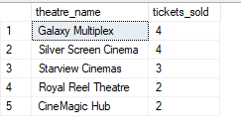
--15 Average revenue per showtime
SELECT st.showtime_id, m.title AS movie_name, SUM(b.total_amount) AS revenue
FROM Showtime st
JOIN Movie m ON st.movie_id = m.movie_id
JOIN Booking b ON st.showtime_id = b.showtime_id
GROUP BY st.showtime_id, m.title
ORDER BY revenue DESC;
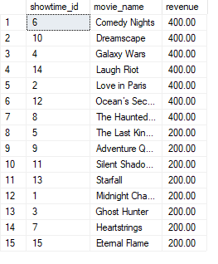

CEP Mapping

K Mapping
K’s | Attributes | How K’s are Addressed Through Our Project
K2 | Mathematics | In this project, basic mathematical logic was applied in SQL queries such as arithmetic operations, seat pricing, and total booking amount calculations. It required reasoning and accurate computations for payments and discount offers.
K3 | Engineering Fundamentals | This project reflects understanding of core database fundamentals including normalization, use of primary and foreign keys, schema design, and data integrity within the Movie Ticket Booking System.
K5 | Engineering Design | We applied engineering design by developing Entity-Relationship (ER) and schema diagrams to structure theatre, movie, and booking modules clearly, ensuring efficient and maintainable database design.
K6 | Engineering Practice | Practical knowledge was demonstrated using Microsoft SQL Server to design, create, and query databases. This mirrors real engineering practice and professional data management skills.
K7 | Engineering and Society | The project promotes social convenience by enabling easy online ticket booking, reducing manual work, and improving user satisfaction — addressing a common societal need for digital transformation.

P Mapping
P’s | Attributes | How P’s are Addressed Through Our Project
P1 | Problem Analysis | We analyzed the challenges in manual ticket booking such as data duplication, lack of seat tracking, and inefficient showtime management. The system addresses these through organized database design.
P2 | Investigation | Research was conducted on how commercial ticketing systems manage data. We examined various sources to identify required entities like Movie, Theatre, Seat, and Booking to build a complete model.
P3 | Design/Development of Solutions | The database schema and ER diagram were designed to ensure real-time ticket availability, secure transactions, and flexible theatre management.
P4 | Modern Tool Usage | We used Microsoft SQL Server and its GUI tools for database creation, data insertion, and query testing, reflecting practical application of modern engineering tools.
P5 | Project Management and Finance | The system simulates real-world financial management through payment and offer tracking, ensuring revenue calculation accuracy for theatres and users.

A Mapping
A’s | Attributes | How A’s are Addressed Through Our Project
A1 | Range of Resources | The project used multiple resources such as database systems, SQL Server, and user data. It demonstrates the ability to integrate technical, logical, and human resources efficiently.
A2 | Level of Interaction | The system connects various entities like theatres, customers, and payments. Relationships between bookings, movies, and showtimes reflect strong logical interaction within the design.
A4 | Consequences for Society and the Environment | By enabling digital booking, the system reduces paper ticket usage and minimizes the need for manual operations, promoting eco-friendly and efficient service delivery.
A5 | Familiarity | This project extended academic learning into a real-world database application, helping us understand relational data modeling, transaction handling, and interface design.

